**Name: Ashish Acharya**

**CWID: 50337433**

**Class Name: BUSA 379- Business Process Management**

**Assignment Name: Final Project Date: 12/06/2023**

**Value Chain Description:**

The Customer Registration value chain starts with effective marketing to attract potential customers. It then proceeds to gather essential customer details, validate and process the data, and confirm registrations through verification emails. Successful confirmation leads to prompt account activation, granting immediate access to products or services. This streamlined process ensures a seamless onboarding experience, creating value by establishing a direct connection between the customer and the business, setting the stage for ongoing interactions and services.

**As-Is Process Description:**

The Customer Registration Process begins when a user intends to create an account. Users navigate to the registration page, where they provide personal details. A validation gateway assesses data accuracy, allowing progression if valid or redirecting for correction if invalid.

After successful form submission, the System/Administration phase takes over. The system validates registration data for accuracy and generates an account confirmation email. Simultaneously, it monitors new registrations, ensuring a dynamic response to user activity.

Upon dispatch of the confirmation email to the customer, the registration enters its final phase. The System/Administration verifies registration details, activating the account if all requirements are met. This meticulous process ensures a seamless transition from user initiation to a confirmed and activated account.

In conclusion, the customer's receipt of the account confirmation email signifies the completion of the registration. This well-designed process not only guarantees data accuracy and security but also establishes an efficient link between the customer and the business, laying the groundwork for ongoing interactions and services. The emphasis on a streamlined and customer-centric registration experience underscores its significance.

**Bottlenecks:**

The execution of a process instance might be delayed due to a shortage of resources: When an activity is ready for execution but all resources are already allocated, the execution has to wait. The following table shows activities that were delayed:

**As-in simulation results:**

In our simulation of customer registration process, we used a multiple day format. This meant that we simulated for 90 days. In these 90 days we distributed eighty hours evenly between the customers and the system/admin department. The simulation results offer a detailed overview of the Customer Registration Process, emphasizing its cost-effectiveness. Most tasks incur minimal expenses, notably with activities like visiting and submitting the registration form having no associated costs. However, the simulation points out that "Verify Registration Details" and "Validate Registration Data" are the most time-intensive tasks, each taking 45 and 30 minutes, respectively.

The section on frequency and probabilities highlights the frequent occurrence of customer account creation (196 times), with a high success rate of 90% in data validation. Resource allocation involves 100 customer employees available at no cost and 50 System/Admin employees incurring a rate of €50.00 per hour. Over the 90-day simulation, potential bottlenecks are identified in the System/Admin and Customer roles.

The scenario analysis underscores the significance of System/Admin and Customer roles, with a total cost of €583,116.67 during the 90-day period. While the process demonstrates overall efficiency, the identification of bottlenecks suggests opportunities for optimization. This optimization aims to improve resource utilization and streamline the registration workflow, as evidenced by the simulation results.



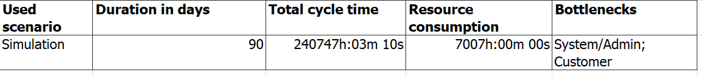

**Identify the criteria and the possible changes for redesign:**

Implementing automated data validation tools is essential to boost efficiency and accuracy. Establishing a gateway system to promptly identify and flag invalid data helps to end the registration process, minimizing errors. To address high execution costs, tasks can be optimized or automated, reducing manual validation time and costs. Identifying and optimizing tasks with prolonged execution times, such as the 45-minute verification of registration details, further enhances efficiency. Recognizing bottlenecks in system/admin and customer roles prompts workflow reevaluation, allowing for task redistribution, hiring, or automation to improve overall efficiency. Additionally, assessing event frequency and probabilities, like data validation issues, enables proactive system enhancements to reduce errors and automate processes, streamlining the validation workflow.

**To-Be Model:**

The updated **To-Be Model** aims to incorporate automated data validation tools to identify and rectify registration errors, streamlining the registration process. The adoption of these tools will also lead to a reduction in manual validation time and associated costs for tasks related to verifying account details. The revised model targets a decrease in the time required for critical steps, aiming to generate the Account Confirmation Email in 10 minutes, send the confirmation email in 5 minutes, and monitor incoming registrations in 5 minutes. Consequently, the administrative workload is expected to decrease, and adjustments have been made to the required resources, reducing them to 75.

Additionally, changes have been made to the resources and costs for the customer department, now set at 75 employees and 10 euros, respectively. Furthermore, execution costs for tasks like sending the confirmation email, monitoring incoming registrations, and activating accounts have been reduced to 5 euros each. An investment of 10 euros has been allocated for automation tools that monitor personal details during the registration process.

**To-Be Model Simulation:**

The 90-day simulation of our current user registration process revealed an average cycle time of 185,379 hours and 31 minutes, pinpointing bottlenecks in the Customer and System/Admin stages. Costs totaled €187,900.00. Notable tasks like entering personal details and activating accounts incurred both time and monetary expenses. Users create accounts daily (196 times in 90 days). Data validity checks showed a 95.00% probability of valid data and 5.00% for invalid data. Resource allocation for Customer and System/Admin roles indicated 75 employees each with different work schedules and costs. The proposed to-be process model aims to streamline registration, addressing bottlenecks, improving communication, and optimizing resource allocation to cut costs and enhance the user experience. Changes will focus on efficient data validation, streamlined communication, and collaboration between Customer and System/Admin roles**.**

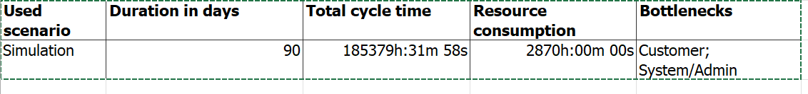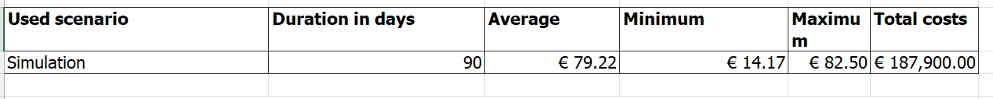

**Comparison:**

The To-Be Model revolutionizes the registration process by integrating automated data validation tools, aiming to streamline and optimize efficiency. These tools target error identification and rectification, reducing manual validation time and costs associated with verifying account details. The model sets specific time goals for critical steps, including generating the Account Confirmation Email in 10 minutes and monitoring incoming registrations in 5 minutes. Resource adjustments involve reducing the workforce to 75 employees, altering the customer department's resources to 75 employees at €10.00 each, and allocating €10.00 for automation tools. The 90-day simulation exposes an average cycle time of 185,379 hours and 31 minutes, unveiling bottlenecks in the Customer and System/Admin stages. While costs amount to €187,900.00, the proposed enhancements focus on streamlining processes, addressing bottlenecks, and optimizing resource allocation for cost reduction and enhanced user experience.

In the As-Is Model's 90-day simulation, cost-effectiveness is underscored, with tasks like visiting and submitting the registration form incurring minimal expenses. However, "Verify Registration Details" and "Validate Registration Data" emerge as time-intensive tasks, taking 45 and 30 minutes, respectively. Frequent account creation (196 times) with a 90% success rate in data validation is observed. Resource allocation involves 100 customer employees with no cost and 50 System/Admin employees at €50.00 per hour, identifying potential bottlenecks. The total cost over 90 days amounts to €583,116.67. The comparison reveals differences in cycle time, costs, and resource allocation, emphasizing the To-Be Model's potential for efficiency gains and user experience enhancements.

**Benefits of the Redesigned Process:**

1. Efficiency Gains
2. Cost Reduction:
3. Focused Resource Allocation
4. Enhanced Data Validation

**Drawbacks of the Redesigned Process:**

1. Initial Investment
2. Resource Imbalance
3. Dependency on Technology